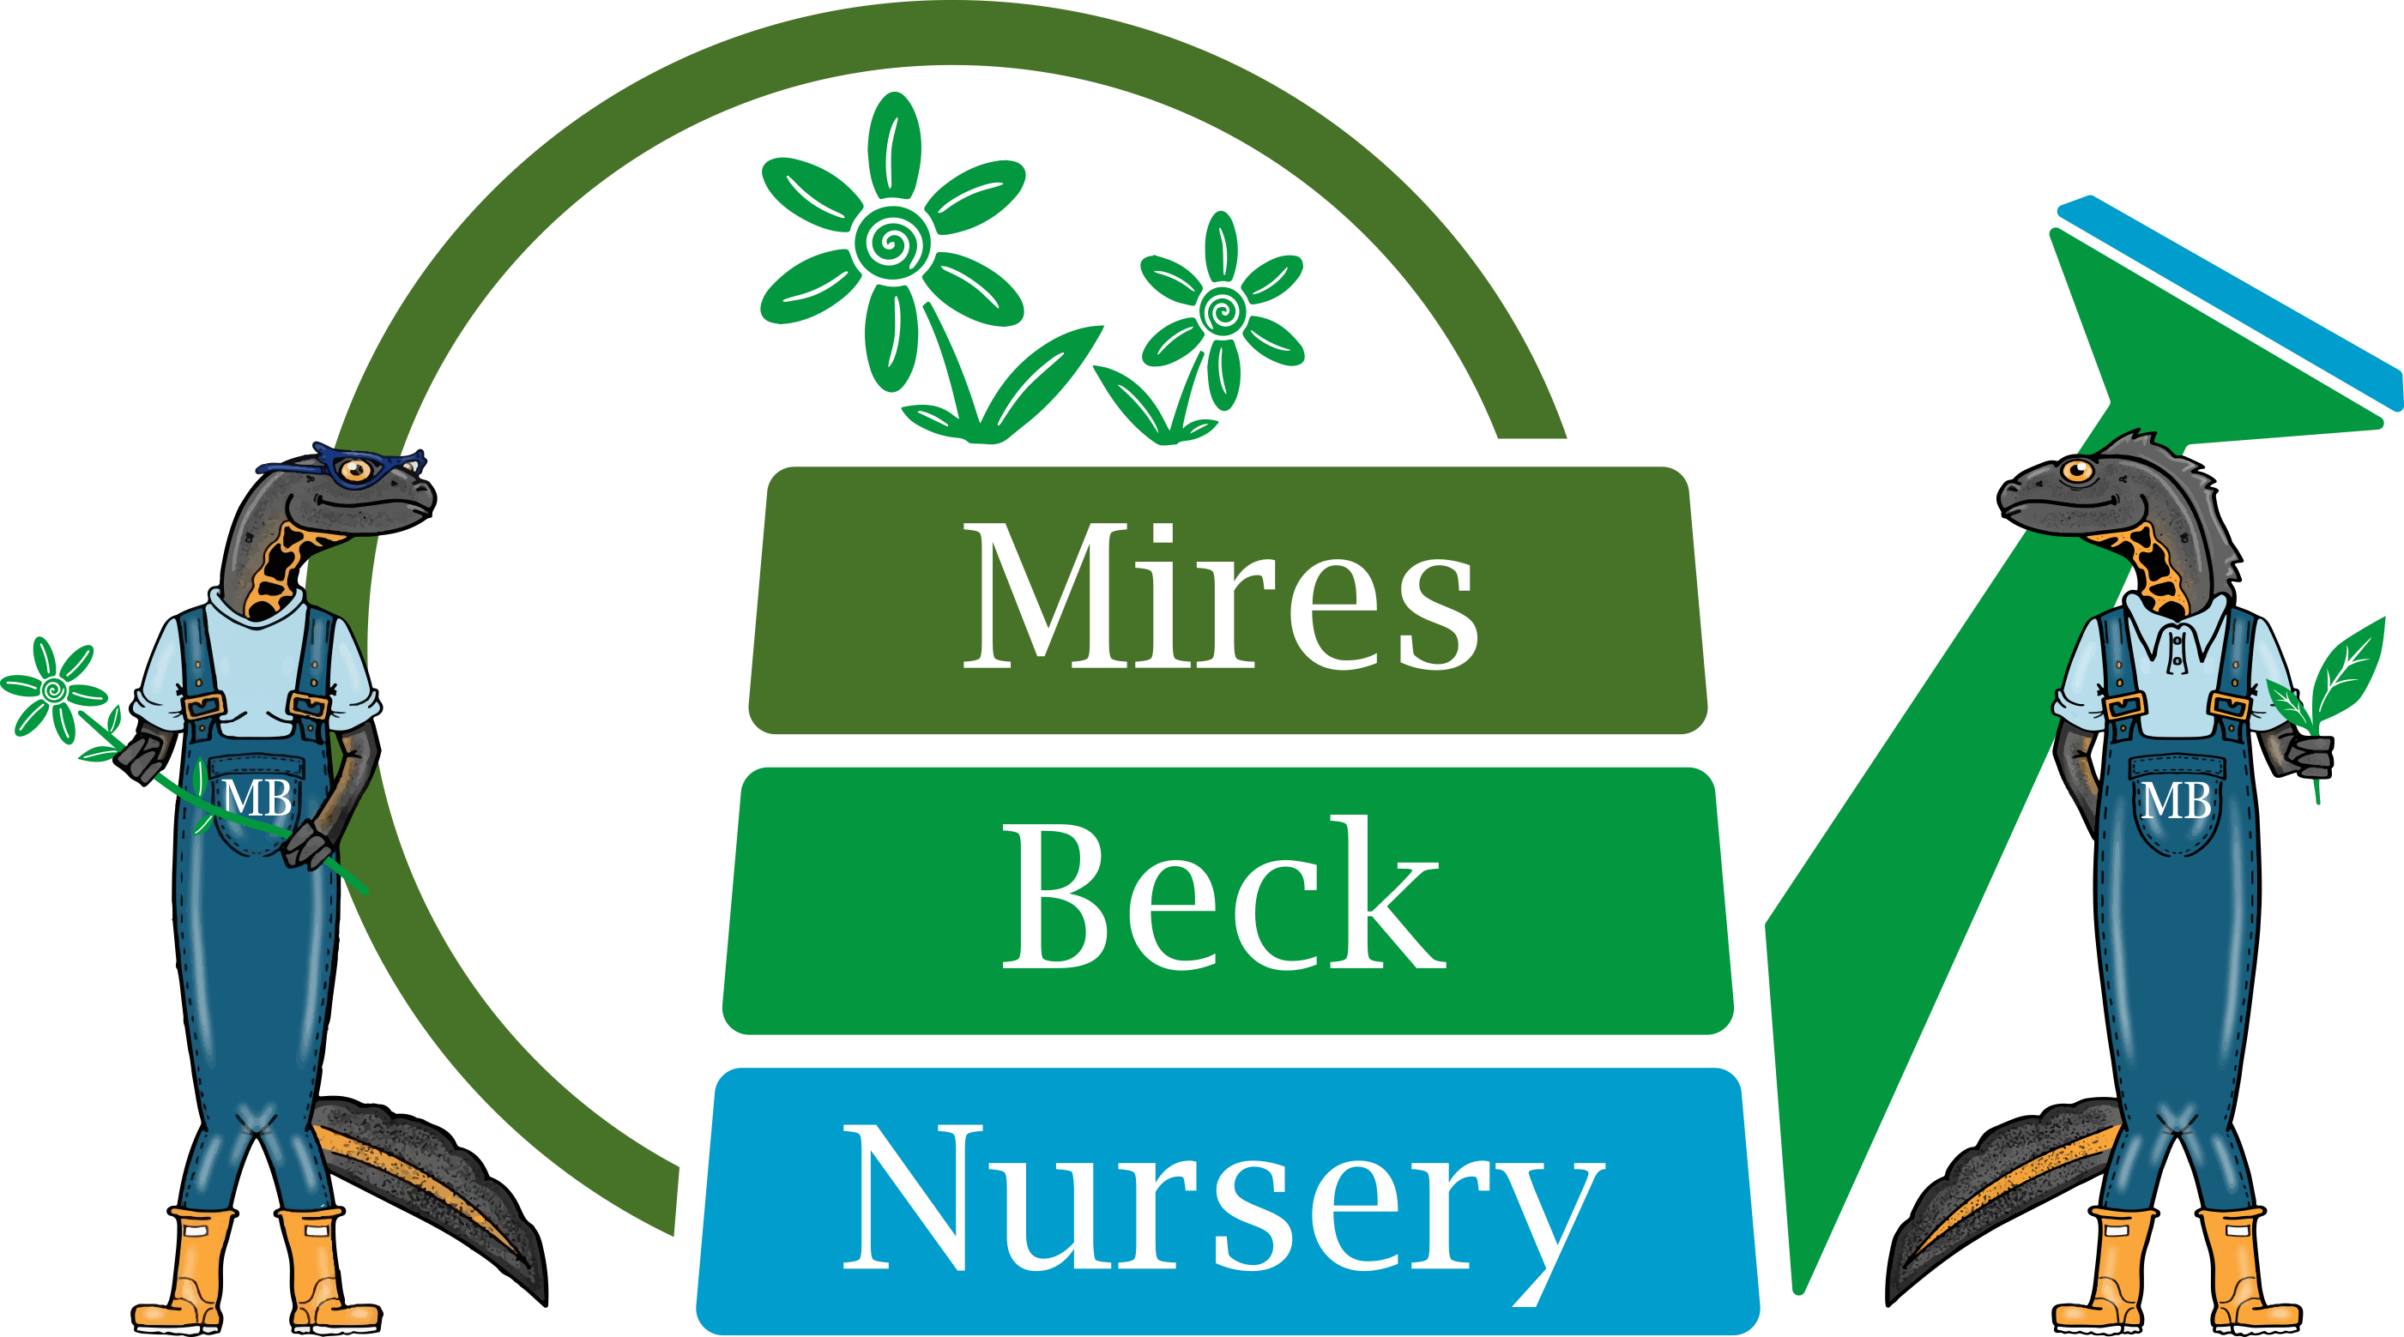

Retail Assistant
Job Description

This is a seasonal role from March until the October 2024. The hours are 9.30 am to 4.30pm. You will be responsible to the Retail Team Leader.

The specific duties of the Retail Assistant are:

- Greet and welcome onsite customers, dealing with enquiries and providing advice where appropriate.
- Collecting wholesale orders for customers.
- Process sales, dealing with customers on an individual basis.
- Carry out end of day processing and update the appropriate records.
- Open and close the nursery at the beginning and end of the day at weekends and bank holidays.
- Dress and maintain sales benches.
- Maintain the area around the sales benches including planted areas.
- Keep the sales hut clean and tidy.
- Ensure that the sales benches are watered appropriately.
- Ensure that the sales beds and glasshouses are watered appropriately over the weekends in accordance with instruction from the Team Leader.

- Produce bed labels and labels for onsite plant sales.
- Processing payments for courses and events and assisting the course leaders where necessary.
- Assisting with shows and events.
- Monitoring stock levels of consumables for the till and card processing machine.
- Ensure compliance with Health and Safety Regulations in own work area.
- To undertake appropriate, and mutually agreed, courses of training.
- Other duties involved in the general running of the nursery.

This Job Description will be reviewed and developed on a regular basis, at least annually, to reflect the on-going development of the organisation.

Signature……………………………………. Date……………………………….

Date Prepared: April 2016
Date Reviewed: January 2024

